SAJIN SHAJI
S/o Mr. Shaji Joseph.
Punnilathil House,
Puthuveli P.O,
Kottayam Dist, Kerala,
Pin: 686641
+91- 9496936765 , 7356341307
04822-244609
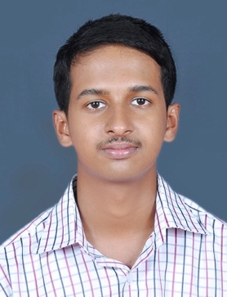
Email: sssajinshaji@gmail.com

Objective | To build a career that offer challenge and growth with opportunities to enrich my knowledge and skills while contributing my best to the organization I work for.
Academic | 2015 B.E Computer Science And Engineering  Secured 58.00% (with degree)  Anna University  Satyam College of Engineering And Technology  Aralvoimozhi, Kanyakumari  2011 Plus Two  Secured 69.00 %  Kerala higher secondary Board.  St Peter’s Higher Secondary School, Elanji  2009 SSLC  Secured 74.00%  Board Of Public Examination Kerala.  Bappuji Higher Secondary School, Koothattukulam
Achievements . | - Participated in Quiz event and secured First prize in the National Level Conference on “Recent Trends in Computing Technology”.  - Presented a paper entitled “A Social Compute Cloud :Allocating And Sharing Infrastructure Resources Via Social Networks “ in the “2nd International Conference on Research Vogues in Information And Communication Technologies”

Personal Information

Date of Birth & age  Religion & Community  Nationality  Sex  Languages .  Hobbies | 02-06-1992  Christian, Jacobite.  Indian  Male  English, Malayalam, Hindi, Tamil  Listening music, Reading

Programming . | Languages : C, C++,JAVA  Databases : SQL Server
Computer Awareness . | - Operating Systems: All Versions of Windows and Linux Versions such as Redhat, Ubuntu.  - Office Tools: Microsoft Office
Strong qualities . | - Team work  - Responsibility  - Hardworking
Training Attended and Experience | - Got training in Android Application Development using Java conducted by VI Microsystems PVT.LTD. Chennai.  - 6 months Experience in Technical Support in Liscom Solution Services  - 1 month experience in Process Executive in Federal Bank , Paravur Junction , Aluva
Mini projects . | - Developed a software for QUIZ PROGRAM using java and MySQL.
Main Project . | - Developed a TRACTION Android software using Eclipse 3.7 IDE and SQLite
DECLARATION:

I hereby declare that the details furnished above are true to the best of my knowledge and belief.

Place: Puthuveli
Date : Sajin Shaji

